My birthday present to myself was certainly the most challenging thing I've ever done. 76km in the Addo National Park was one of those life time experiences neither I nor my fellow British friends whos idea it was won't forget.
Dragging ourselves out of bed at 3am to get to the start but thankful of the coffee and lift direct there by our George Trail Running group saw us all head off into the dark at 5am. Luckily I tagged onto a couple of men who had a better head torch than me and made the first 20km fly by with chatter and the gradual sunrise. Feeling good I continued at a comfortable (but in hindsight a bit too fast pace) and tried not to brake too much on the steep loose descents. All was going smoothly, the steep climbs were hands on knees, the river beds were rocky so kept it all interesting and the escarpment overlooking the whole national park was spectacular. Into the unknown 5th hour of racing things started to hurt... quads from the rocky long descents, those first twinges of cramp in my feet and inner thighs and the start of waves of nausea. I was stopping every other stop, roughly 20km apart to fill up 1-2 250ml of water or electolyte (again in hindsight not enough in the humid conditions)and snacking on bananas and bars. However despite slowing down a lot I was still in 2nd place overall and constantly passing runners on the 46km race who'd started later than us and who gave so much support. A long down hill to the final waterpoint was the end of any proper running I was doing... 10km left, a fall that resulted in cramping when I stood back up and other weird sensations I've never had like 'claw hands' where my hands were in constant cramp and I couldn't open them up!! I was so convinced I was going to be caught I was so thankful for the final 5km climb as I knew everyone would be walking. Over the finish line the legs really rebelled and every muscle was twitching with cramp... the doctor came over with a pain killing spray and I had to laugh as I just told me to spray everywhere! I have to say I pushed myself to a place I've not done before and the pain didn't stop at the line... unable to eat as for some reason my jaw was just too tired (?!) and
serious dehydration, a lack of salts, sickness and dizziness meant by 7pm where I thought we'd be in a restaurant with a glass of wine or two, I was curled up on my mattress in the back of the car sucking Rennies and falling into a restless sleep not daring to move much in case I cramped up!! Luckily 12 hours of sleep and a midnight cereal munch can do wonders and now I just have that nice feeling of achievement and excitement that I've found a new world of racing
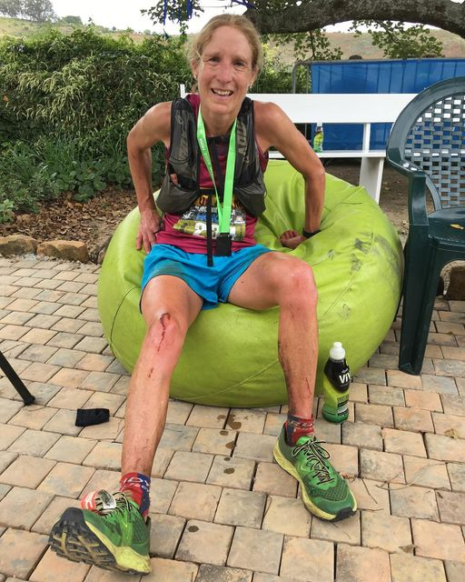

Women’s #Addo76 winner Cath. Williamson took a tumble with 15km to go during a low energy spell but fortunately it wasn’t a deep gash. However, it did result in probably bringing on cramping.
She soldiered on to finish her first long trail race after running a 1:21 road half marathon in her hometown Knysna last weekend.
She took a few moments to work through the discomfort after finishing in 7:43:50.
She ran a road marathon in 3:30 in her native UK last year. Her longest trail training session before today’s big effort was 3.5 hours.
“Next year I’ll put in more time!” she quipped

